Style changes//

Buttons – change all buttons to this format please. buttons- remove shadow, make them this colour #dddddd

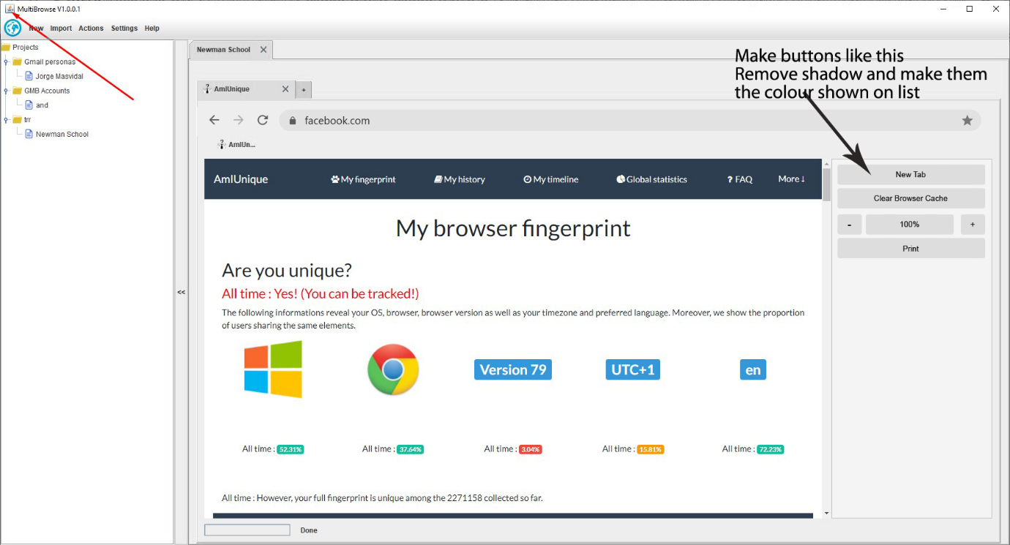

Point 2 - Inactive browser tab colour #cecece  
Point 3 - Active browser tab colour #eeeeee (same also for active profile tab colour, so the live browser tab and live profile tab this colour)  
Point 1 – Make the address bar like this, with rounded corners like in actual chrome browser  
Point 4- make close tab X like this  
Point 6 – Make X for closing a profile tab like this. (slightly larger than browser tab x)

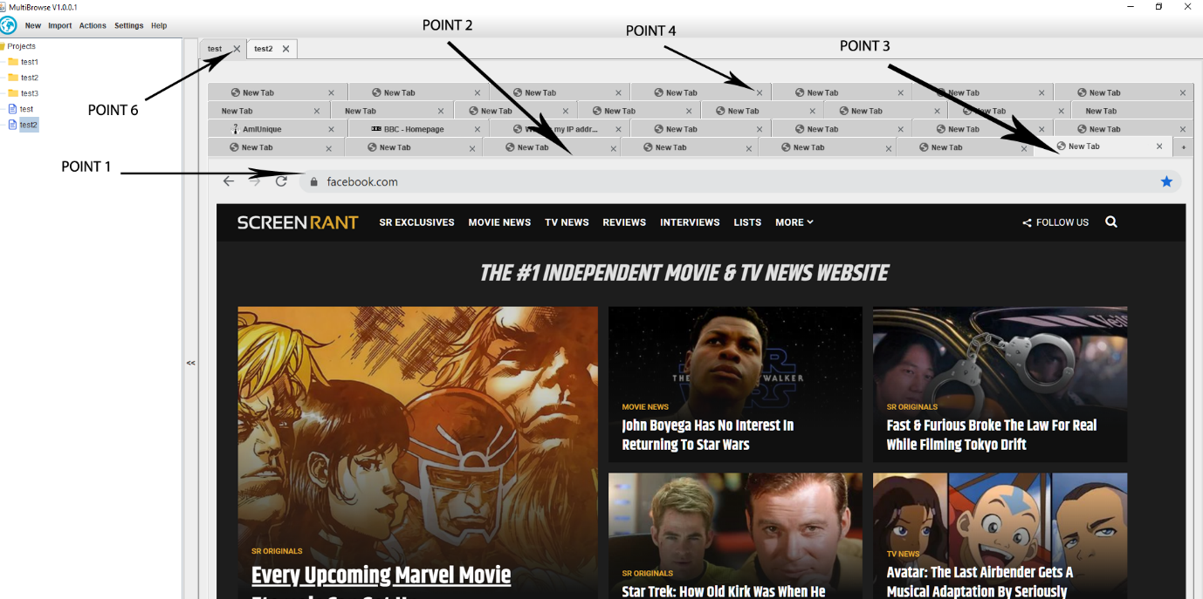

Fix one, reduce window size – when user clicks user agent it can extend in the drop down list past the window size

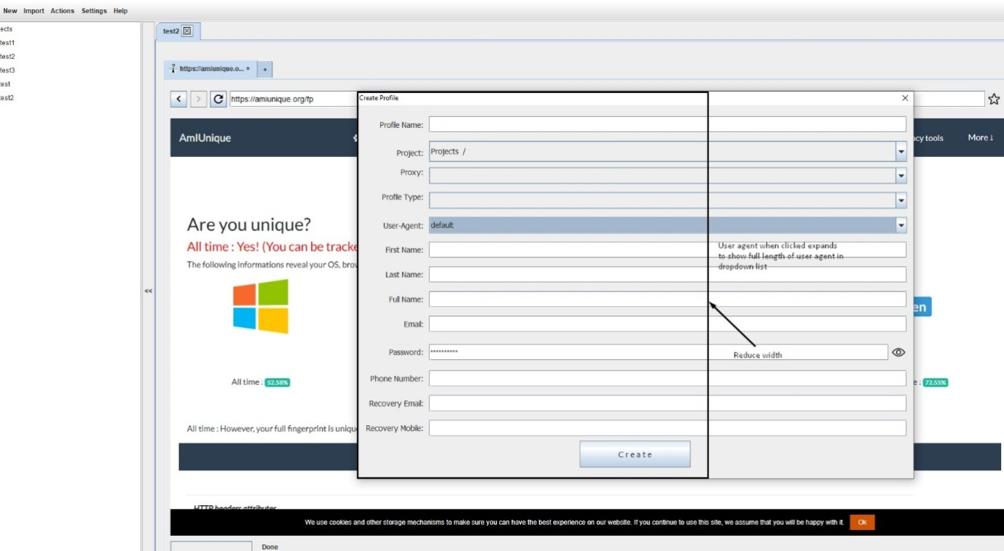

Make window title font, the same size as field headings. For ALL windows.

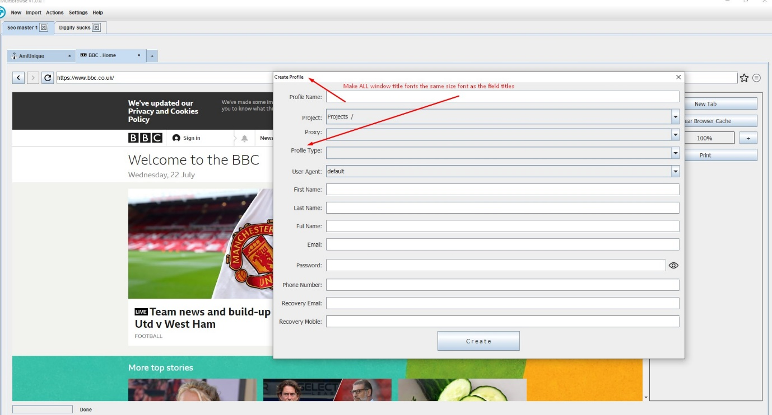

Change text as shown on image. All dialog boxes must have correct heading, not ‘select an option’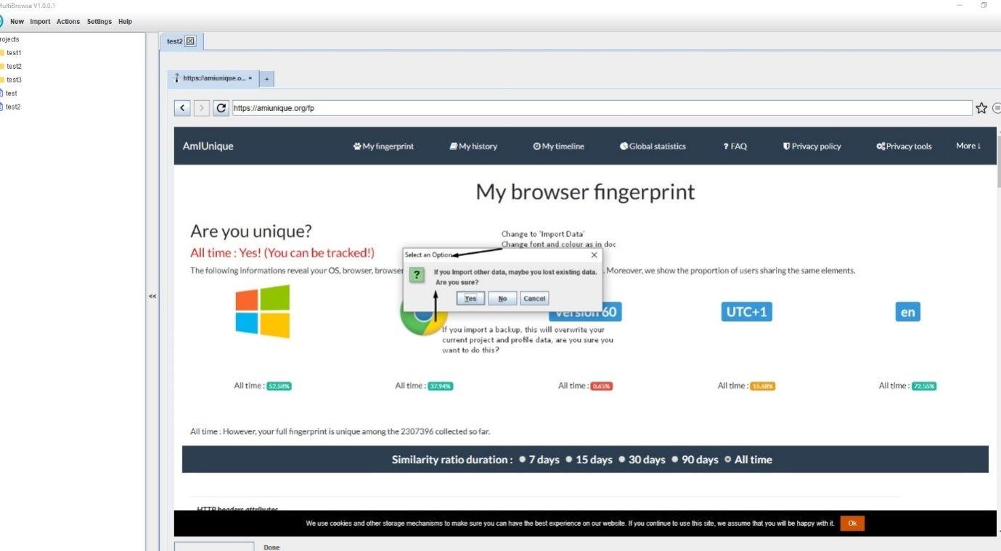

Do as shown on image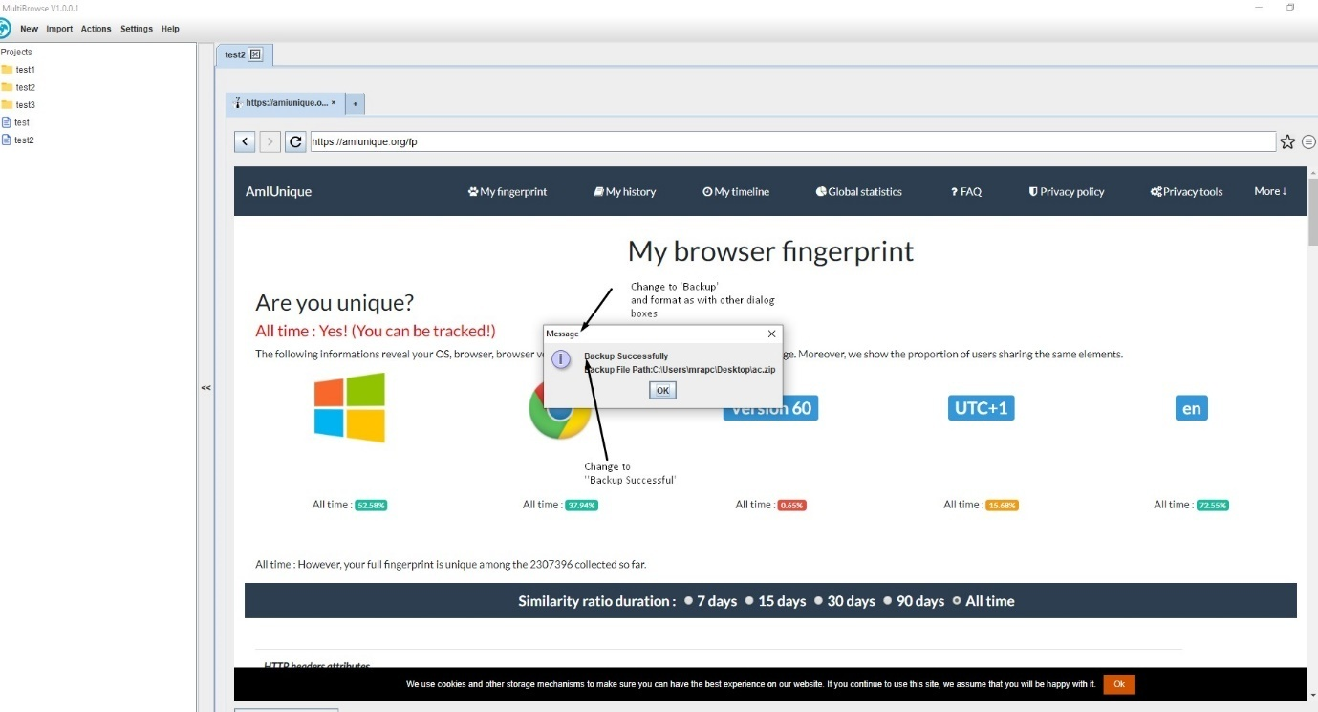

Will supply icon asap and weburl will be <https://www.multibrowse.net> for the Here link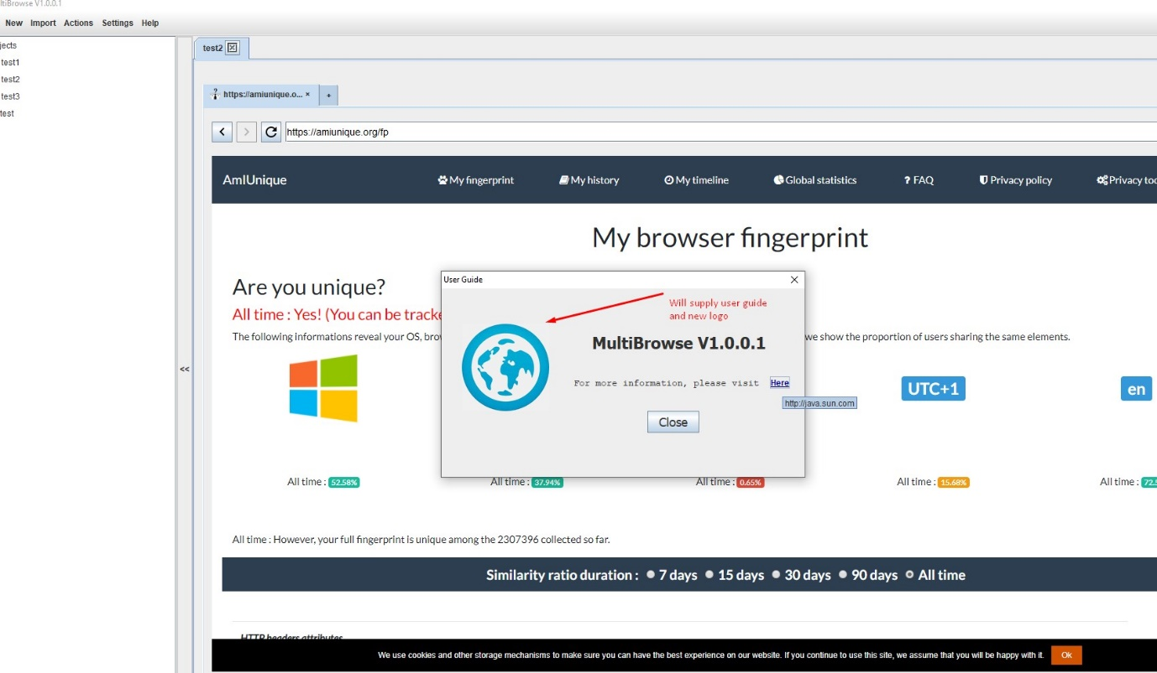

Do as on image please

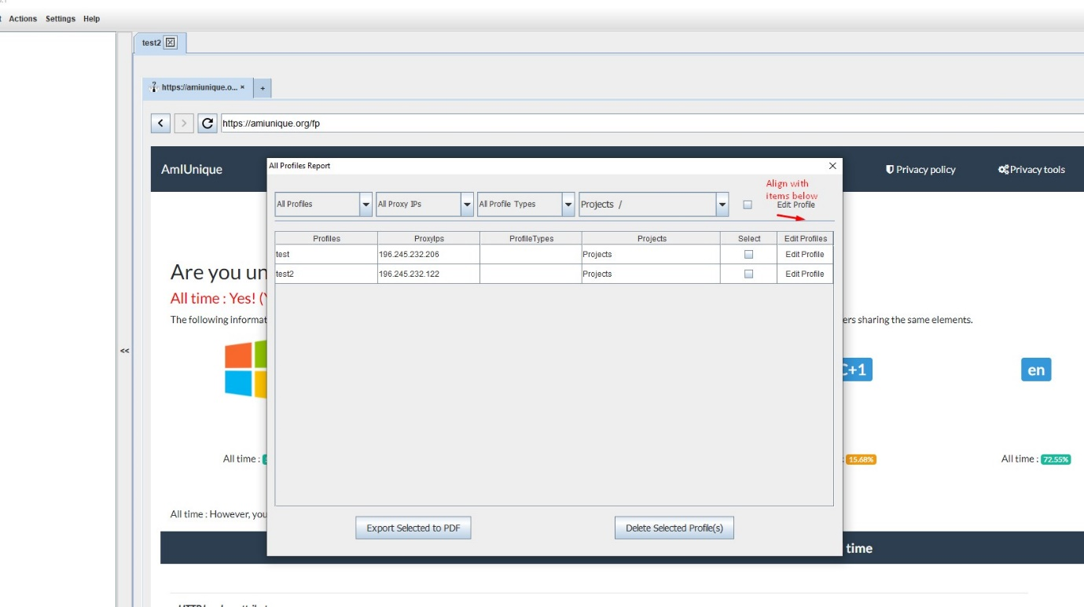

Do as on image please

Do as on image please . 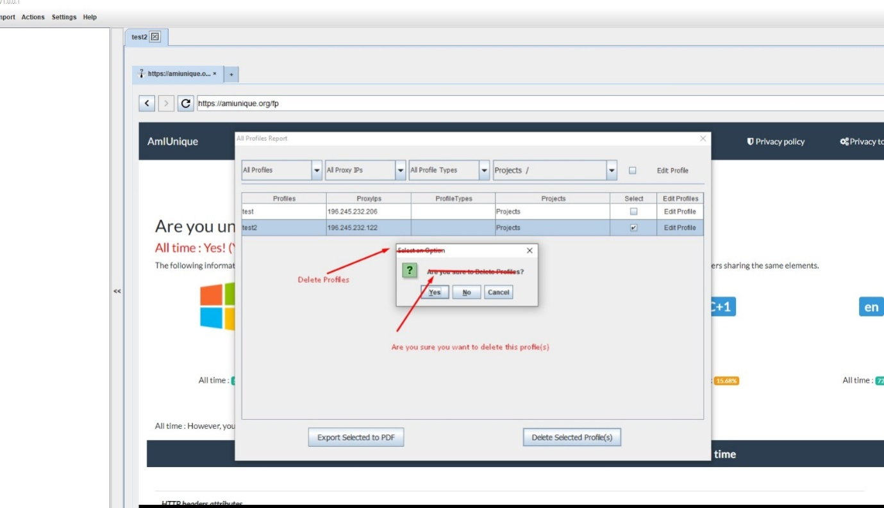

We need to autosave on all data entry forms, or users will lose things. So we need to remove save button and autosave after a record is added or deleted. Realign buttons to the right after save is removed.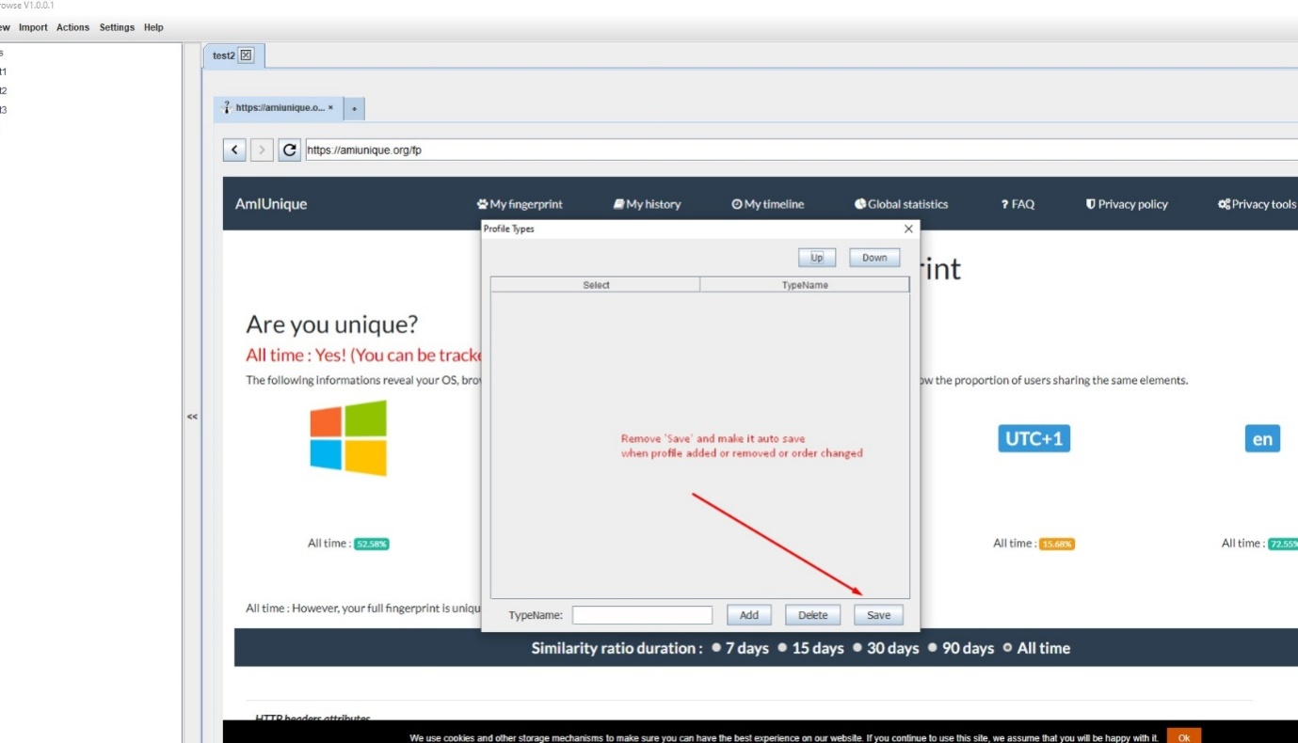

Do as on image please .

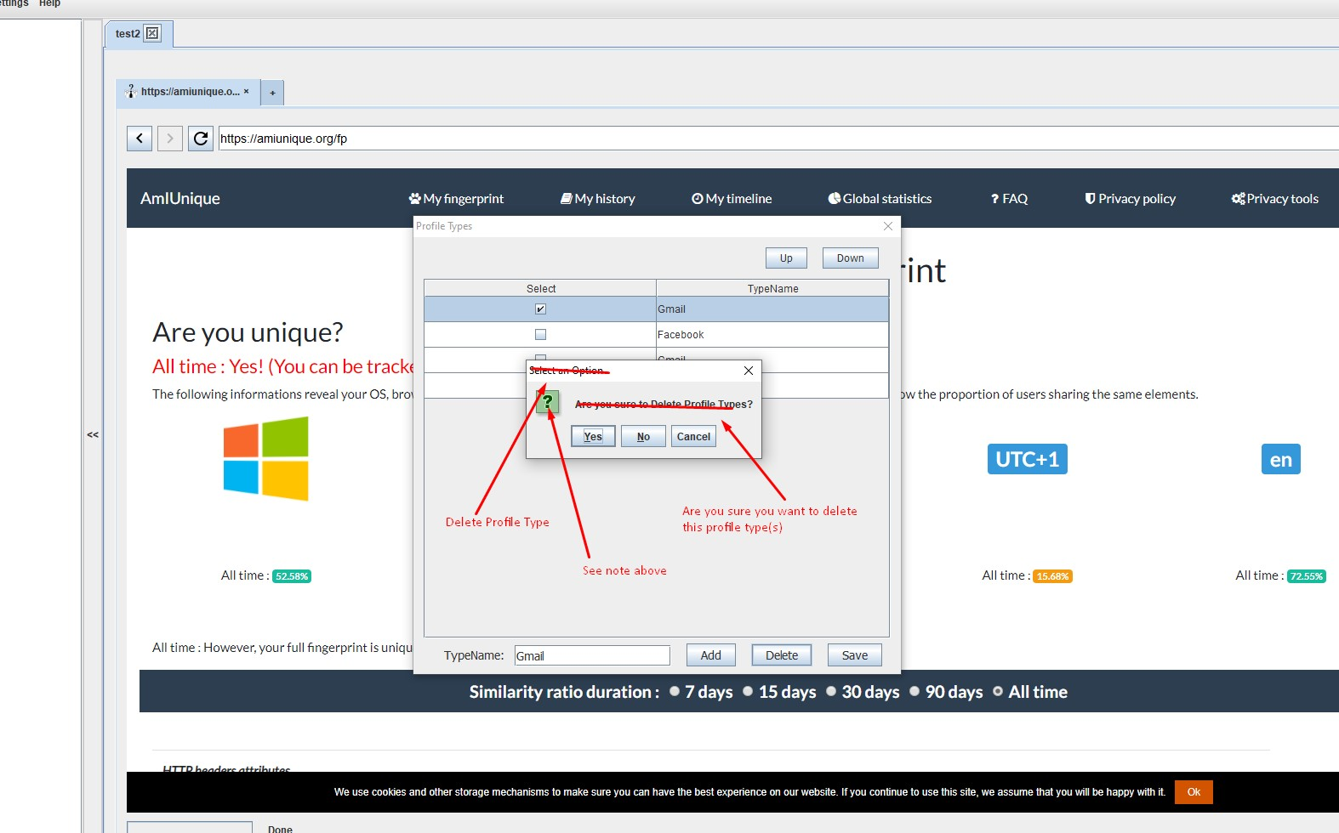

Make the edit profile a standard grey button that fits in the cell with some white border around it to cell edge. Use new button style.

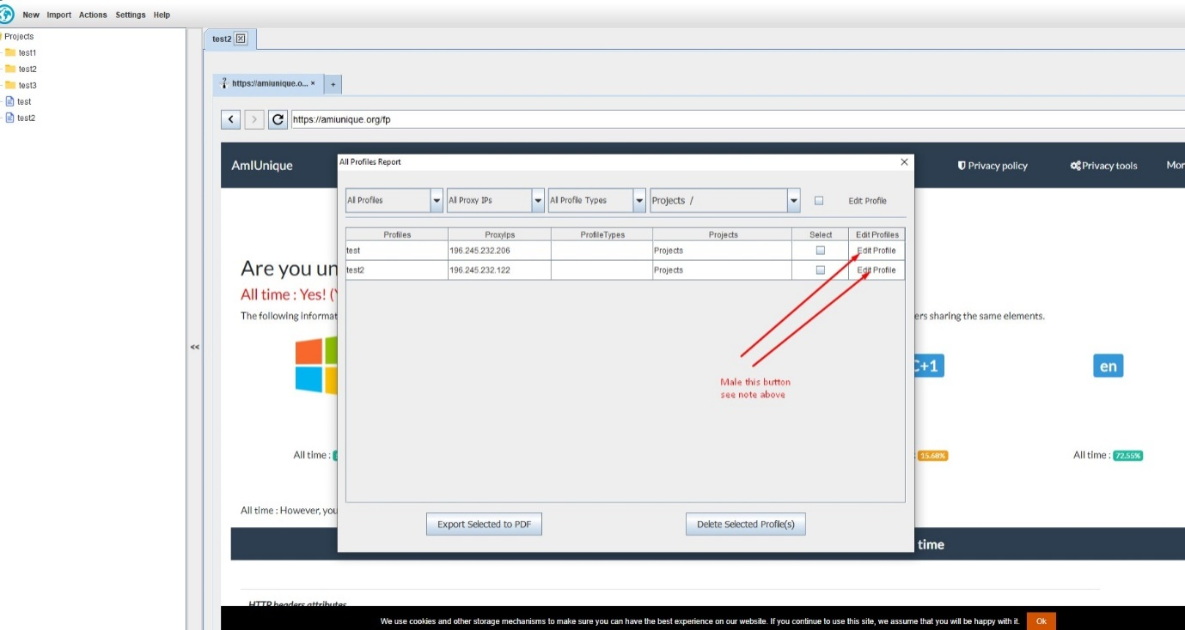

Do as on image please .

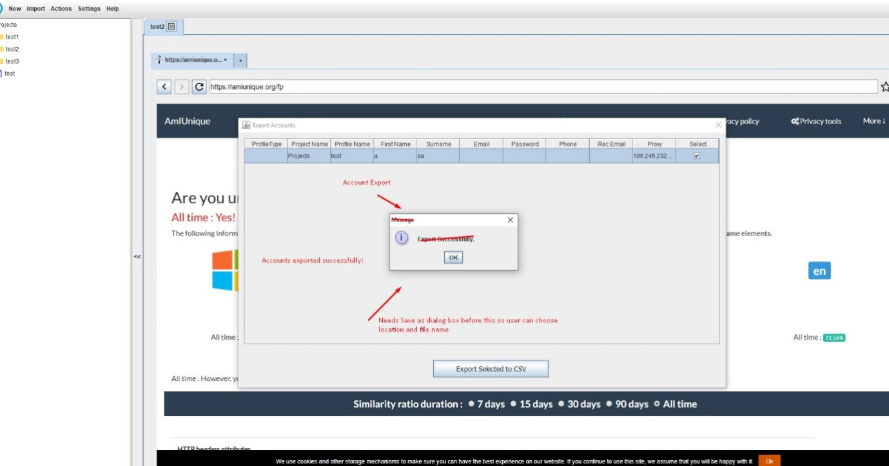

Do as on image please .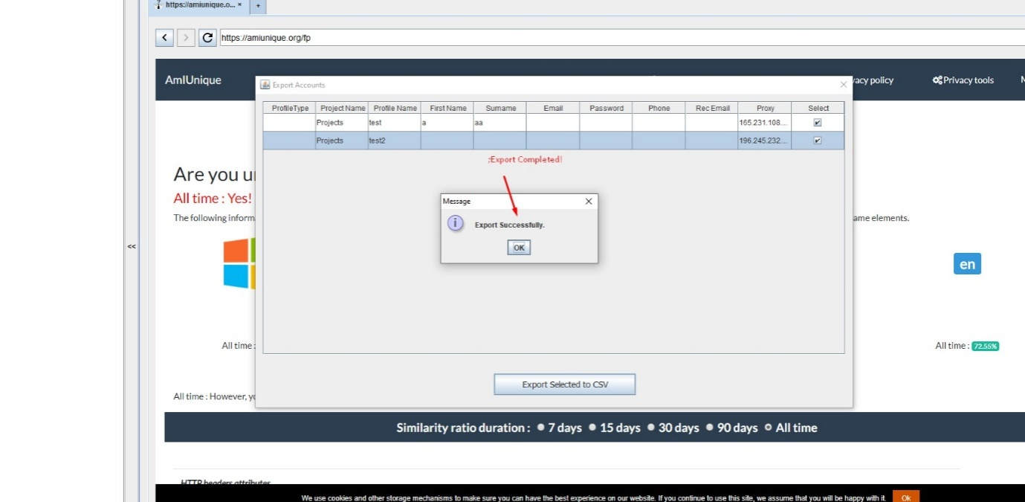

Do as on image please .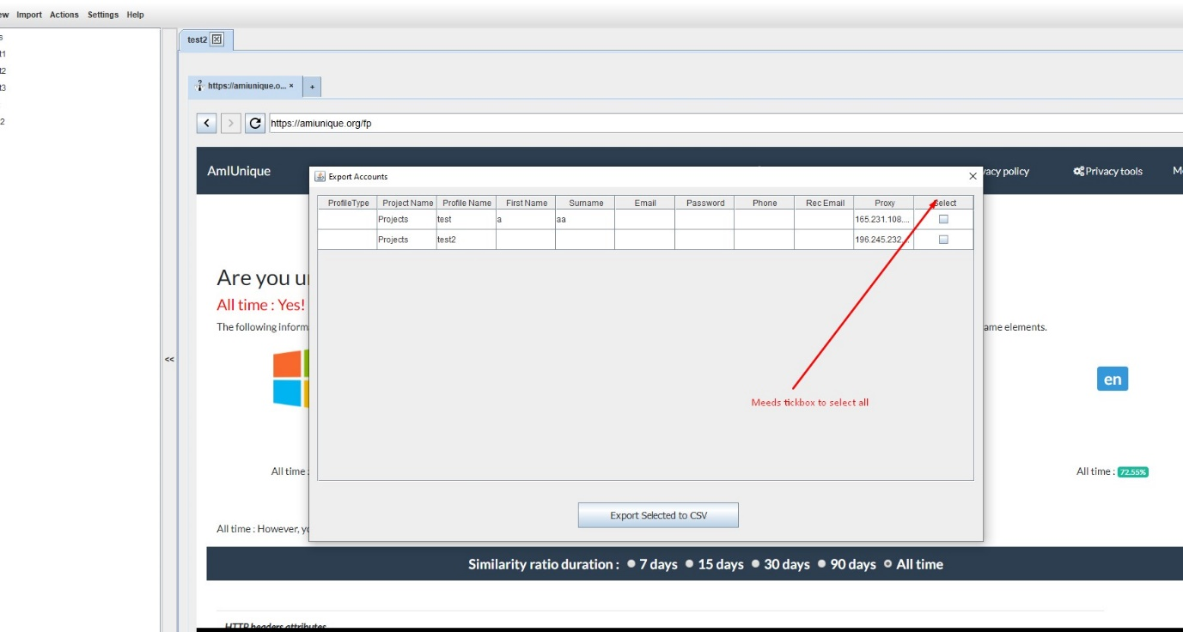

Do as on image please .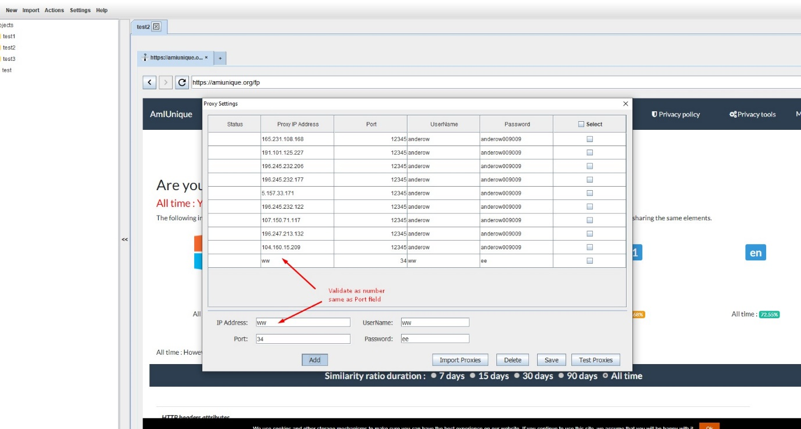

Do as on image please .

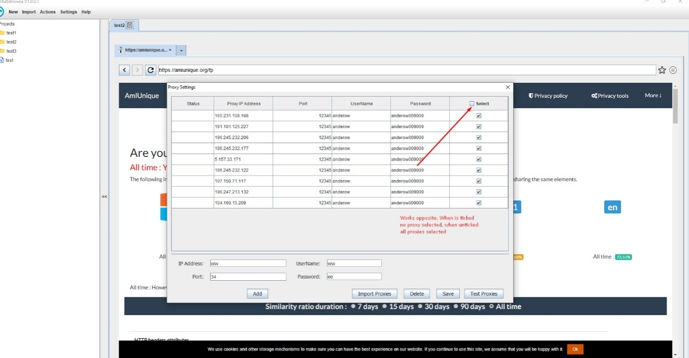

Do as on image please . Import proxy and add proxy should check for duplicates and not import or add if there is an existing proxy

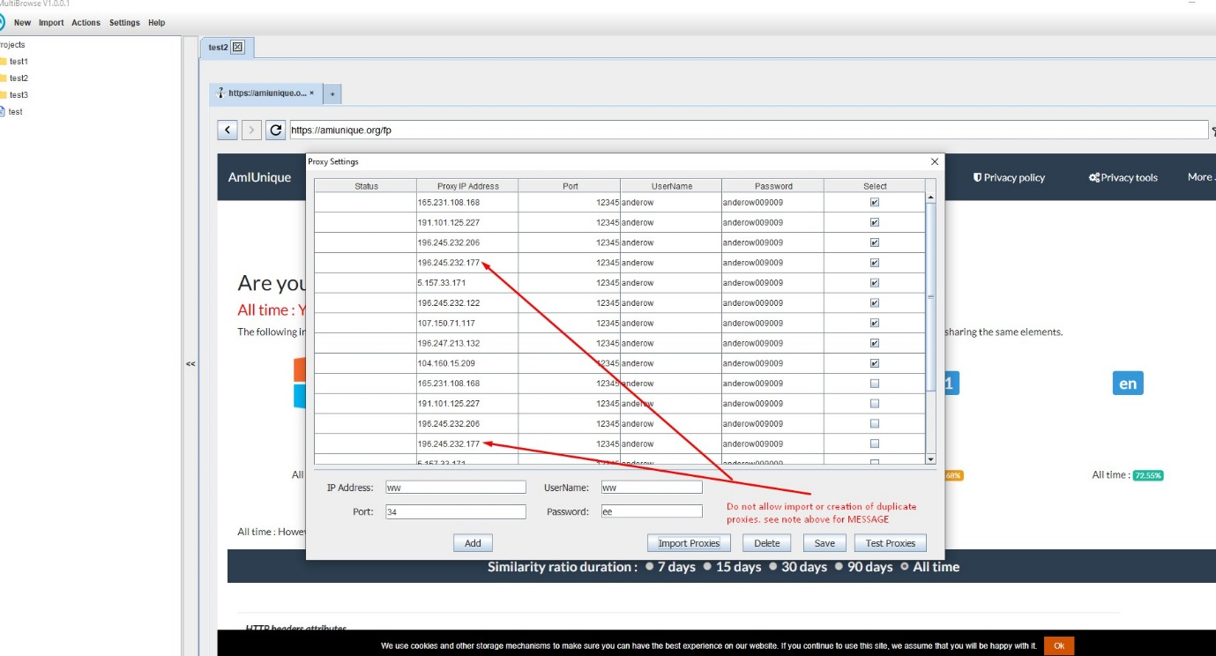

Do as on image please .

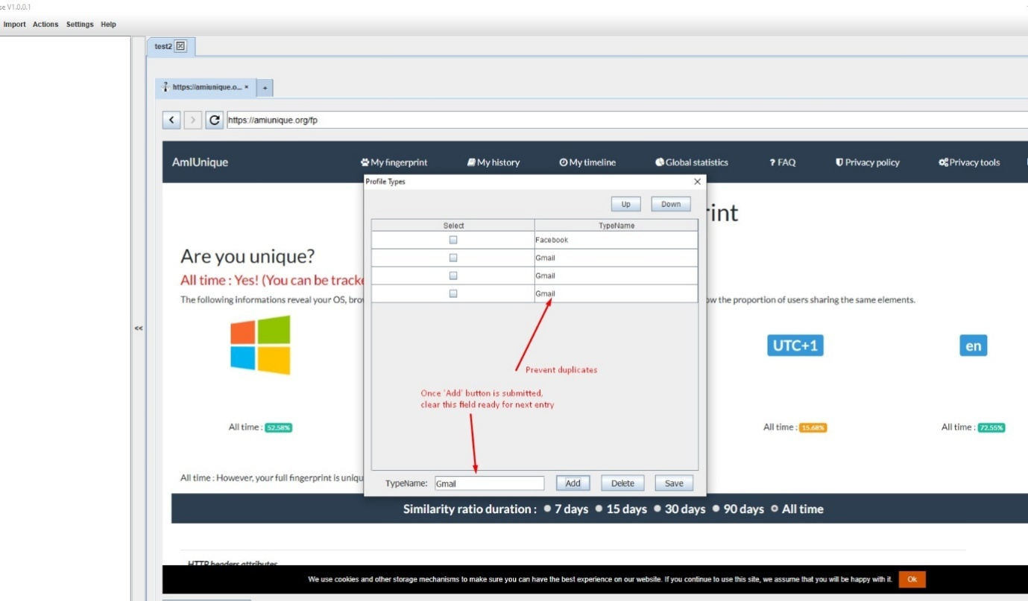

Do as on image please . 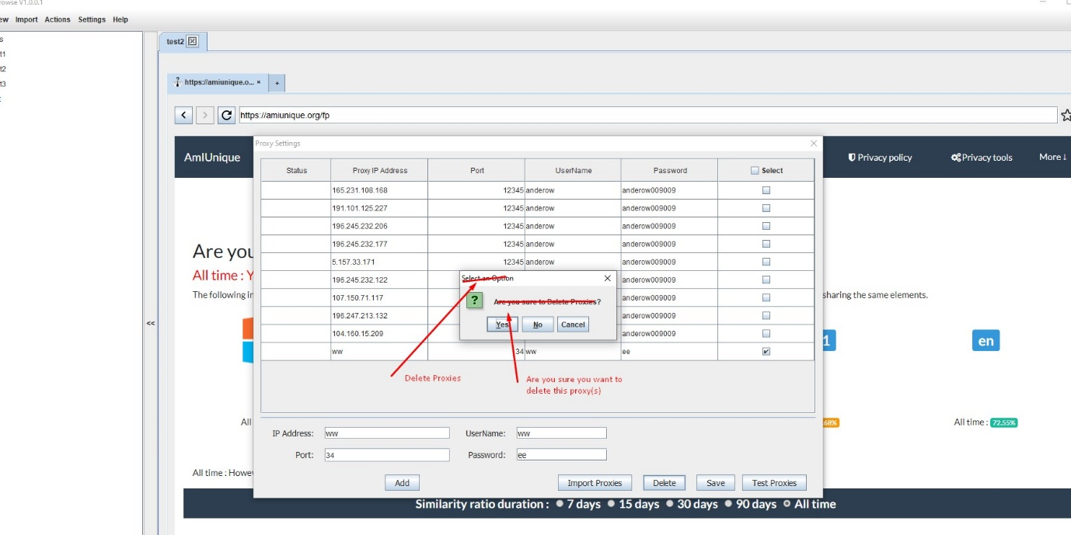

Do as on image please . After adding ‘Save as’ Dialog message, once they have clicked Export, message reads ‘Export Successful’

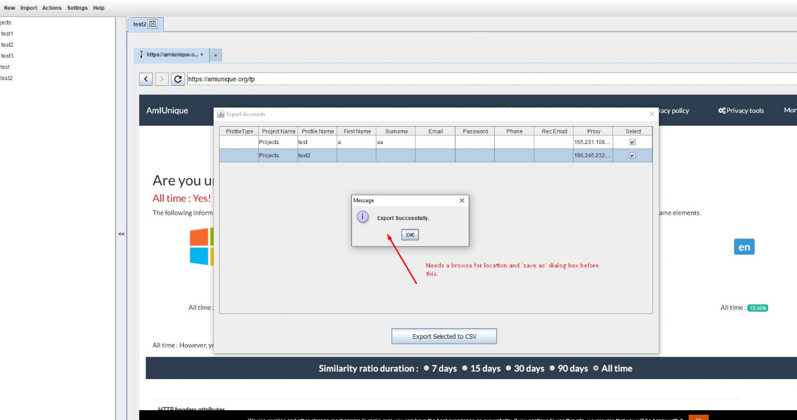

I will supply PDF layout for this

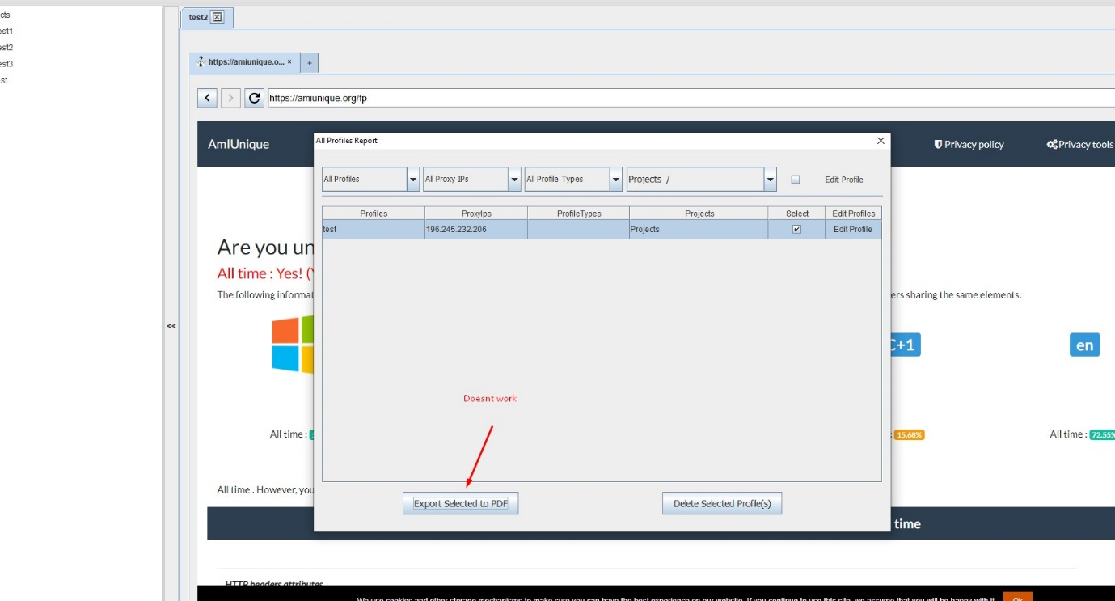

Do as on image please .

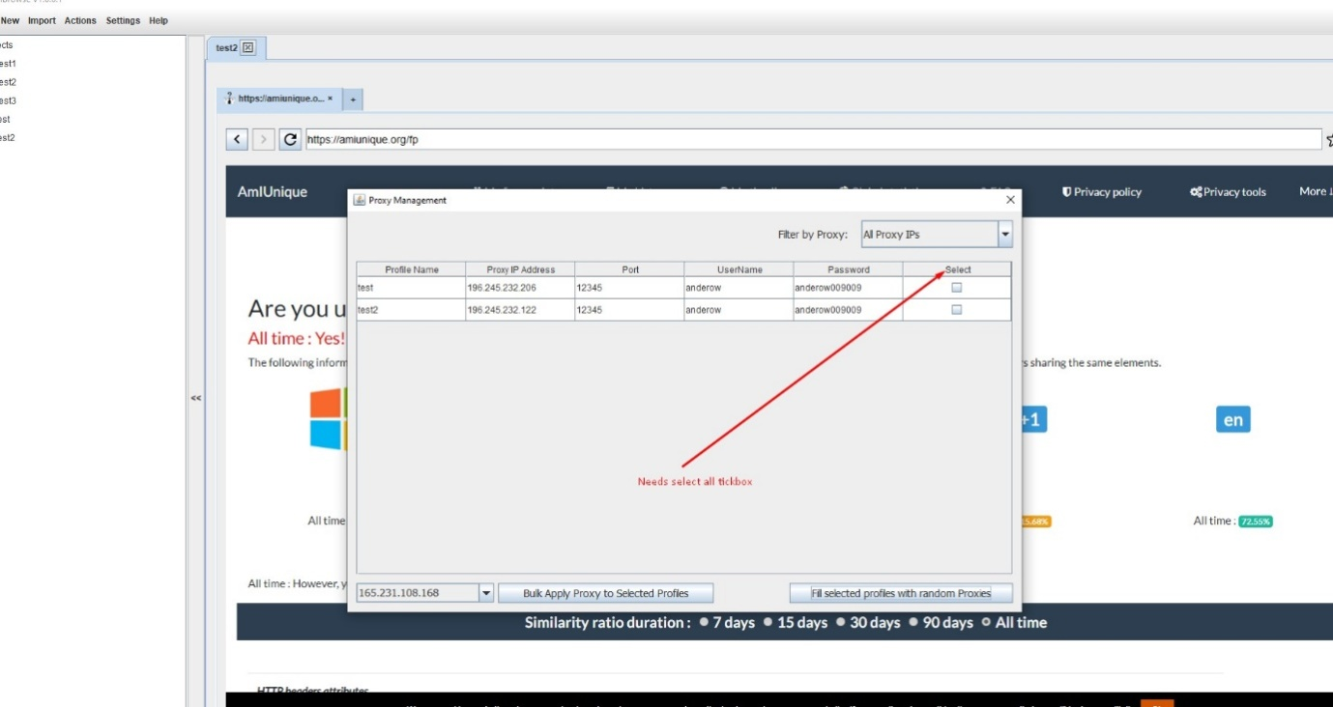

Do as on image please .

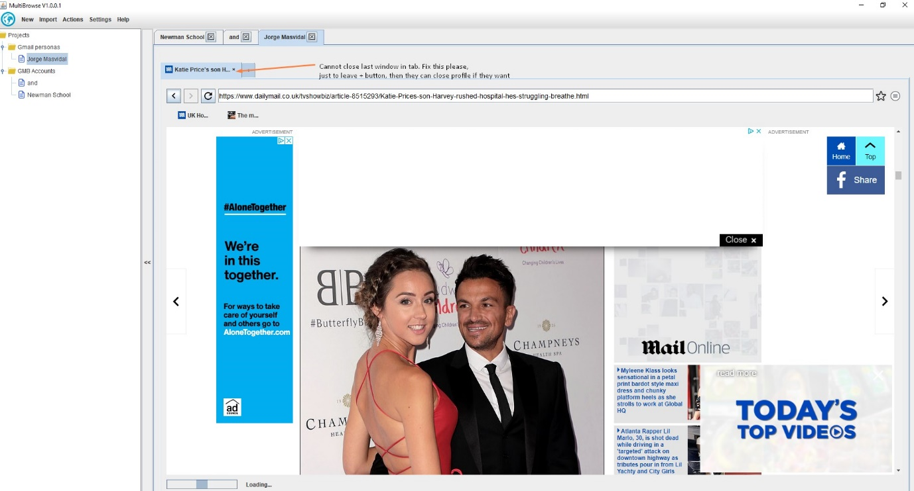

Do as on image please . Add an ‘eye’icon that reveals password, it should be closed eye with password hidden, open eye when password revealed. Do this for User Profile Form also (make the eye different when password shown or hidden). Default state of password is hidden on login form and profile form.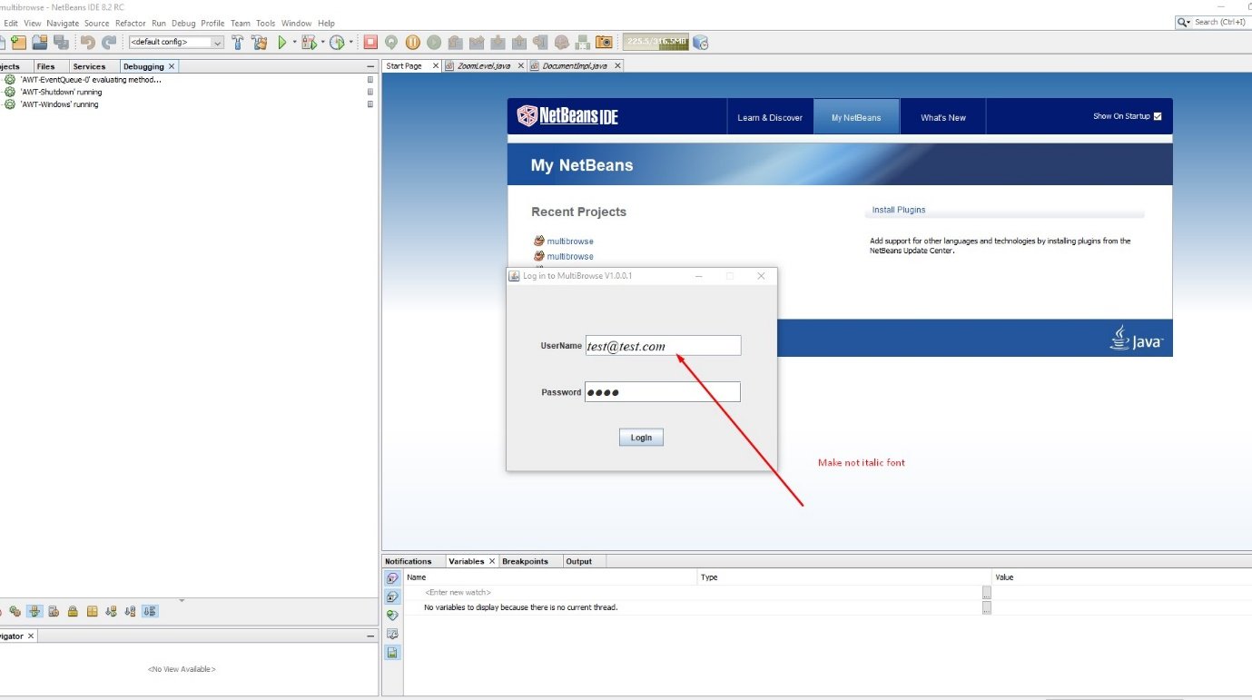

For the next two images. I am waiting for graphics so please do these when I supply new graphics.

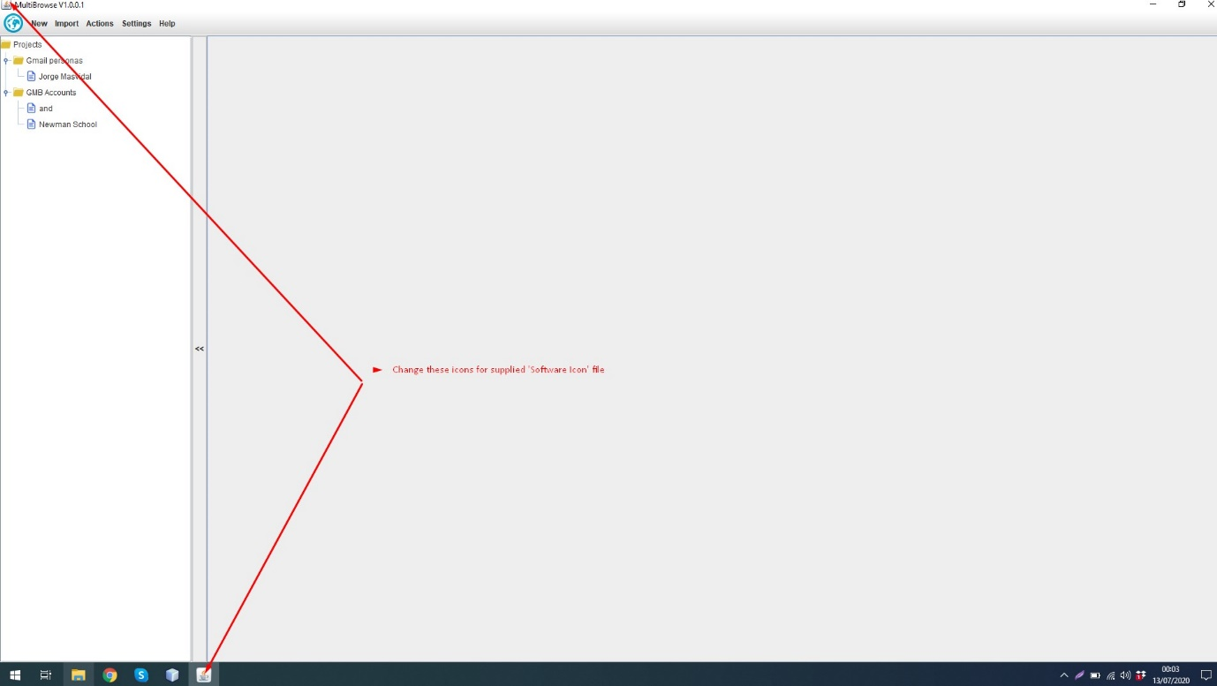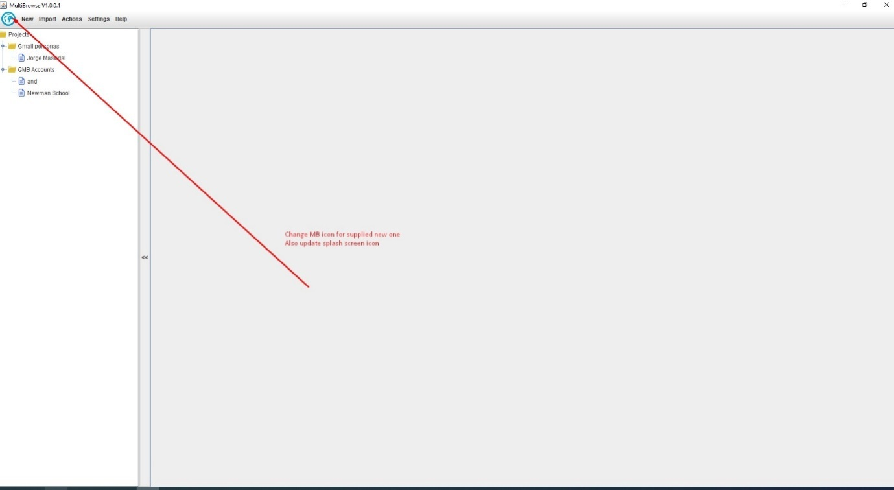

Do as on image please . 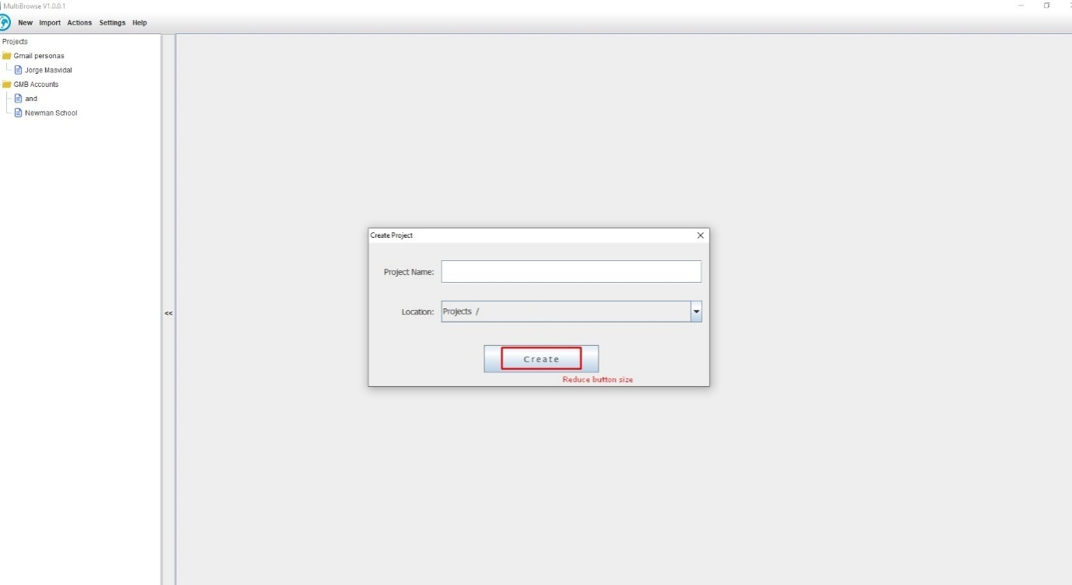

Do as on image please .

Do as on image please .

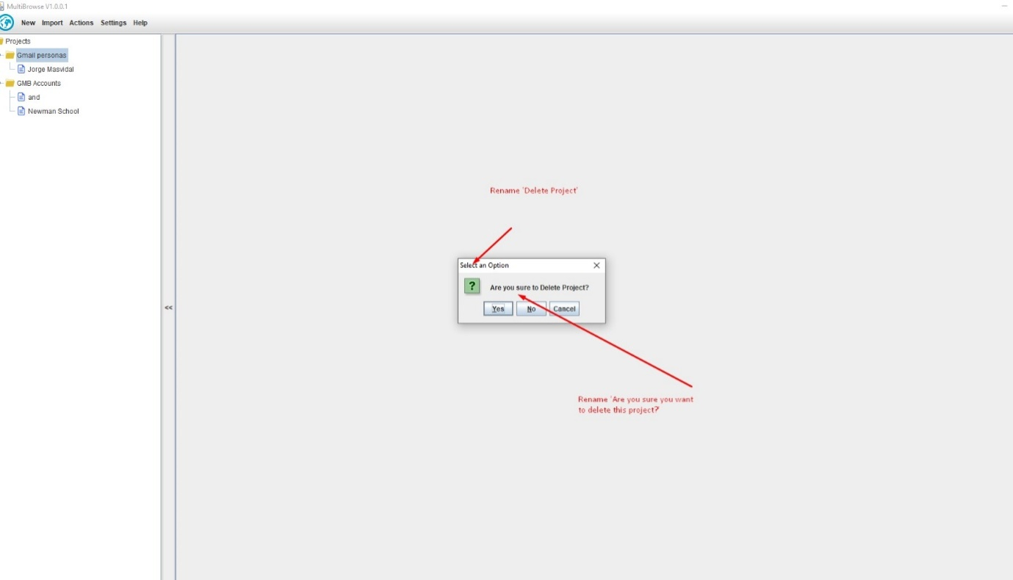

Do as on image please . It doesn’t show Select all tickbox, when you try and click around there this shows. Check all forms Select ALL boxes work.  
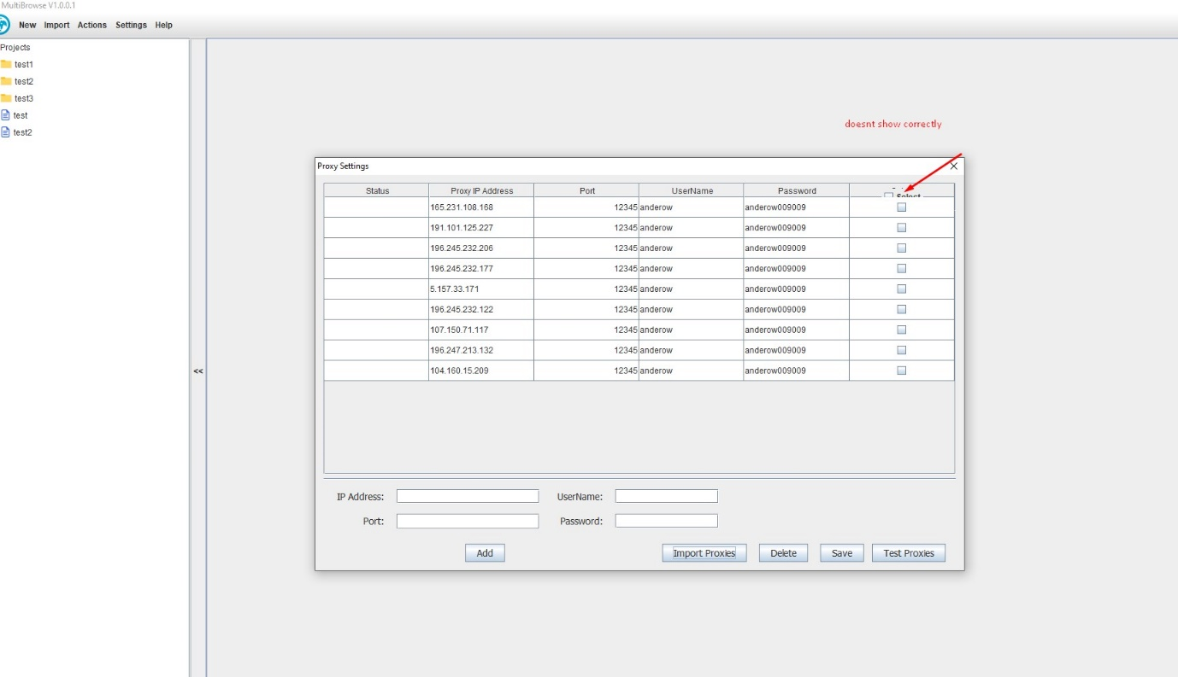

Do as on image please . (this is for delete profile dialogwhen you right click a profile and delete)  
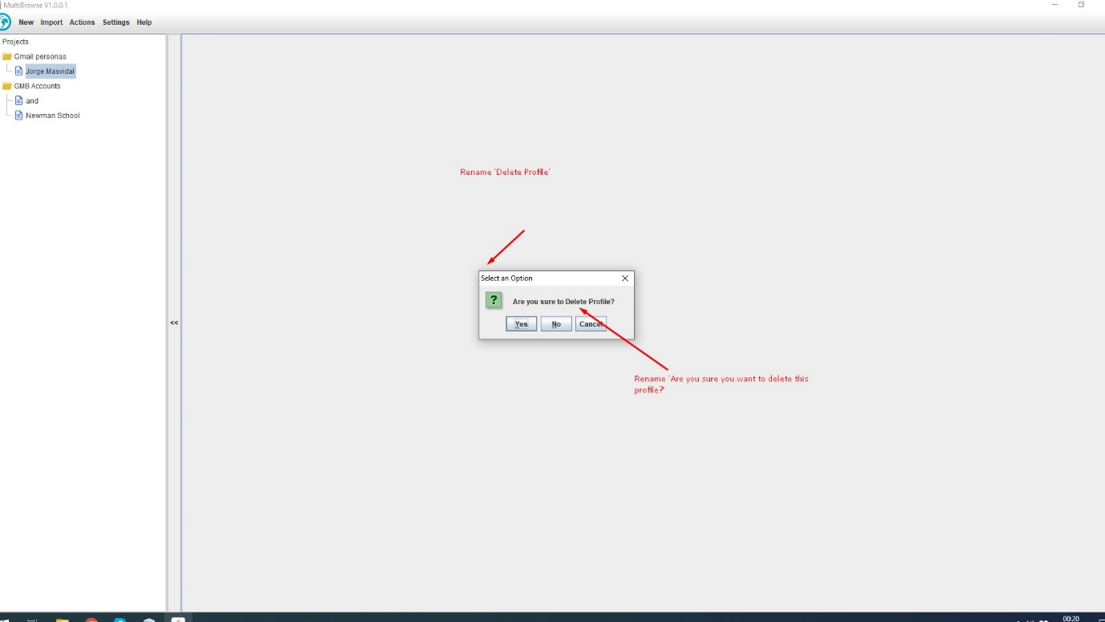  
We need to have field mapping function for importing profiles I think, so if someone has a different format of csv file (for example different column names with correct data) they can map it to MB, so they don’t have to manually change the csv import from browzeo. So for example if data set is in a different order, then can specify put data from column A in MB field B, data from column B in MB field C and so on. I can provide mockup form for this  
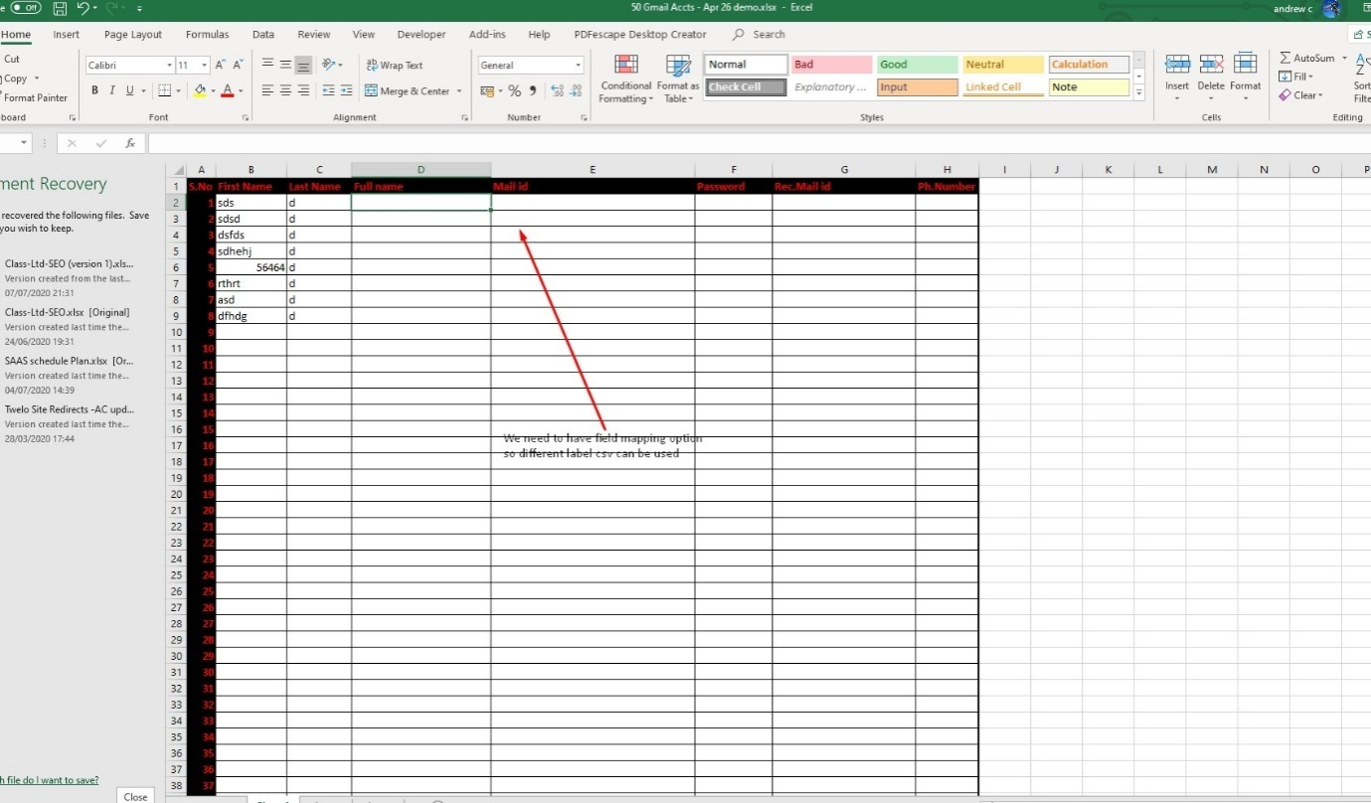

Do as on image please .

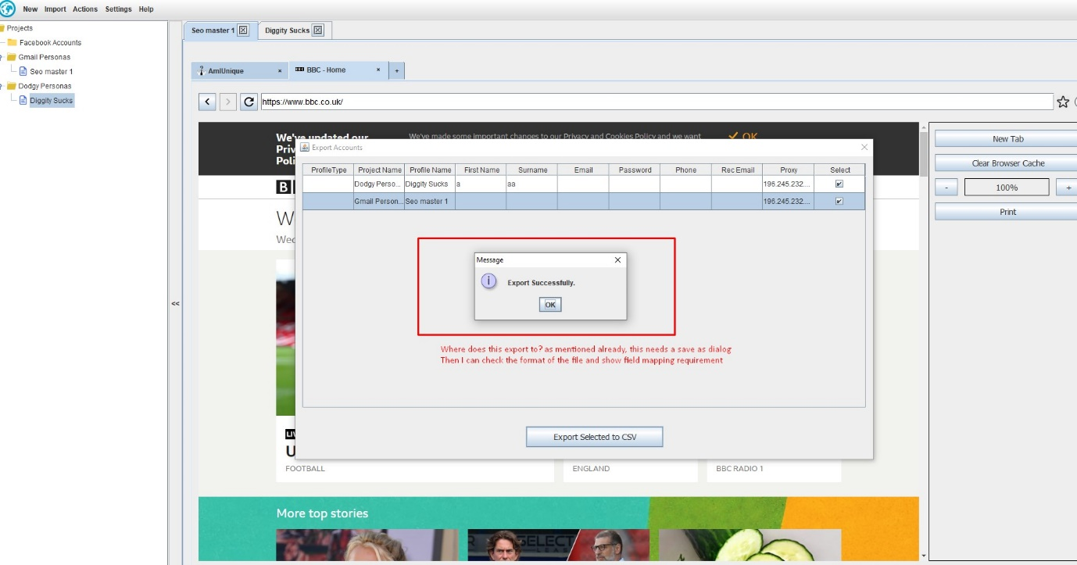

When deleting a project, it should not delete the profiles but instead move them to the bottom of the file tree, ready to be moved to another project. They can select to delete profiles in the profiles menu item

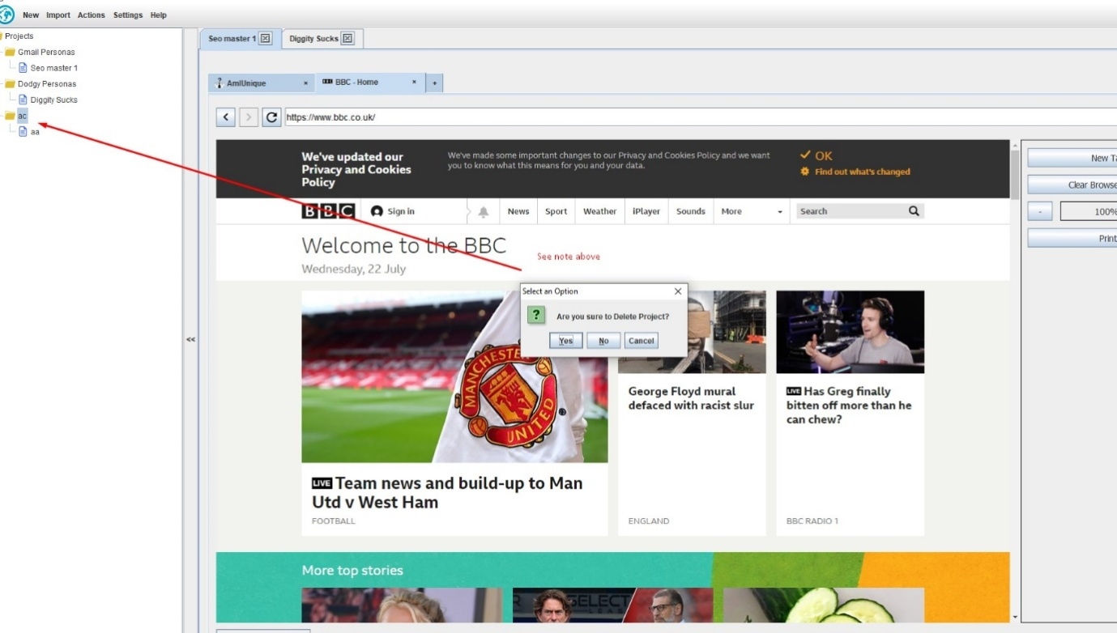

Change the question mark icon for the one supplied in skype. Resize it to correct size first or I can do if you let me know size